**DAILY ONLINE ACTIVITIES SUMMARY**

|  |  |  |  |  |  |  |  |  |
| --- | --- | --- | --- | --- | --- | --- | --- | --- |
| **Date:** | **02-06-2020** | | | | | **Name:** | **Nihal Rafiq** | |
| **Sem & Sec** | **4th A** | | | | | **USN:** | **4AL18CS052** | |
| **Online Test Summary** | | | | | | | | |
| **Subject** | | **---** | | | | | | |
| **Max. Marks** | | **---** | | **Score** | | | **---** | |
| **Certification Course Summary** | | | | | | | | |
| **Course** | **1. Introduction to R**  **2. Step into Robotic Process Automation** | | | | | | | |
| **Certificate Provider** | | | **1. Great Learning Academy**  **2. GUVI** | | **Duration** | | | **1. 2.5 hours**  **2. 3 hours** |
| **Coding Challenges** | | | | | | | | |
| **Problem Statement:**  **1. Write a java program to find perfect sum problem**  **2. Write a program in java, an array of integer data to be initalized** | | | | | | | | |
| **Status: Executed** | | | | | | | | |
| **Uploaded the report in Github** | | | | | **Yes** | | | |
| **If yes Repository name** | | | | | **https://github.com/nihal-art/lockdown-coding** | | | |
| **Uploaded the report in slack** | | | | | **Yes** | | | |

Certification Course Details:

1. I have opted to R certification course.

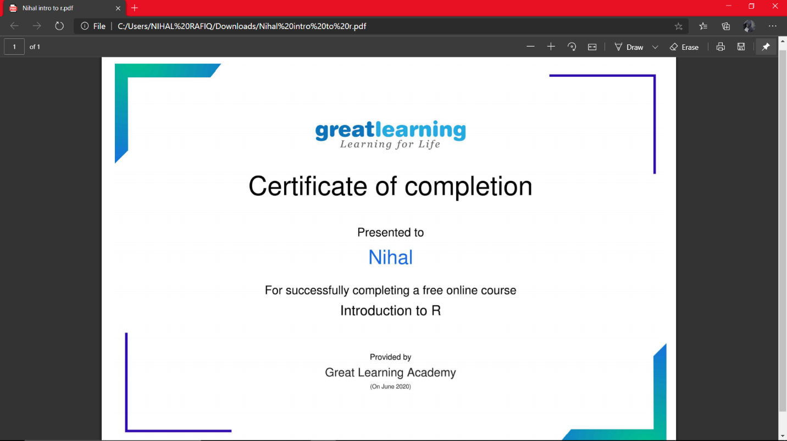

2. Robotic Process Automation

This certificate is awarded for completion of step into Robotic Automation during GUVI’s RPA SKILL-A-THON 2020

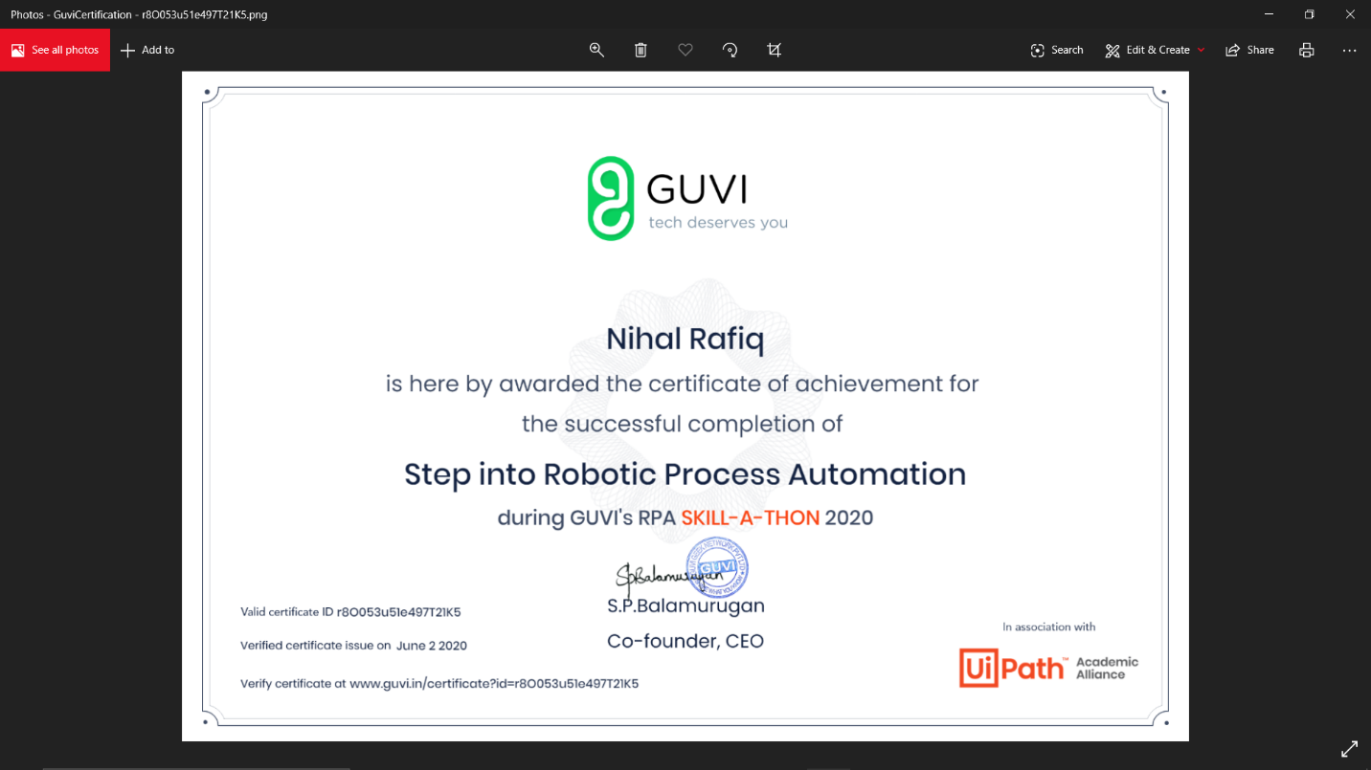

Coding Challenges Details:

**1.** Write a java program to find perfect sum problem.

Given an array arr [] of integers and an integer K, the task is to print all subsets of the given array with the sum equal to the given target K.

Examples: Input: arr [] = {5, 10, 12, 13, 15, 18}, K = 30

Output: {12, 18}, {5, 12, 13}, {5, 10, 15}

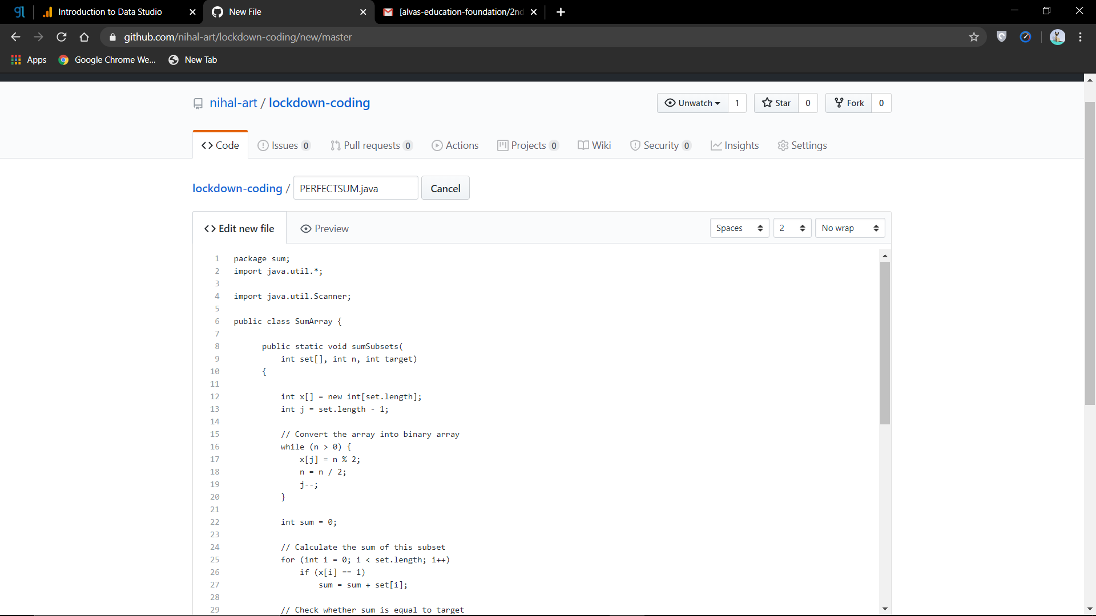

**2.** Write a program in java, an array of integer data to be initialized. During the initialization, if a user enters a value other than integer value, then it will throw InputMismatchException exception. On the occurrence of such an exception, your program should print “You entered bad data.” If there is no such exception it will print the total sum of the array.

